Applying the T-nut wall hanging fixings

Make a hole in the substrate either by pushing through a wide screwdriver (about 8mm) or by using an 8mm drill | 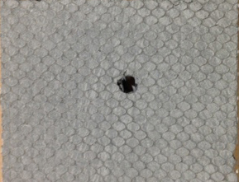
On the front surface of the substrate push the T-nut into the hole pressing the teeth into the board. | 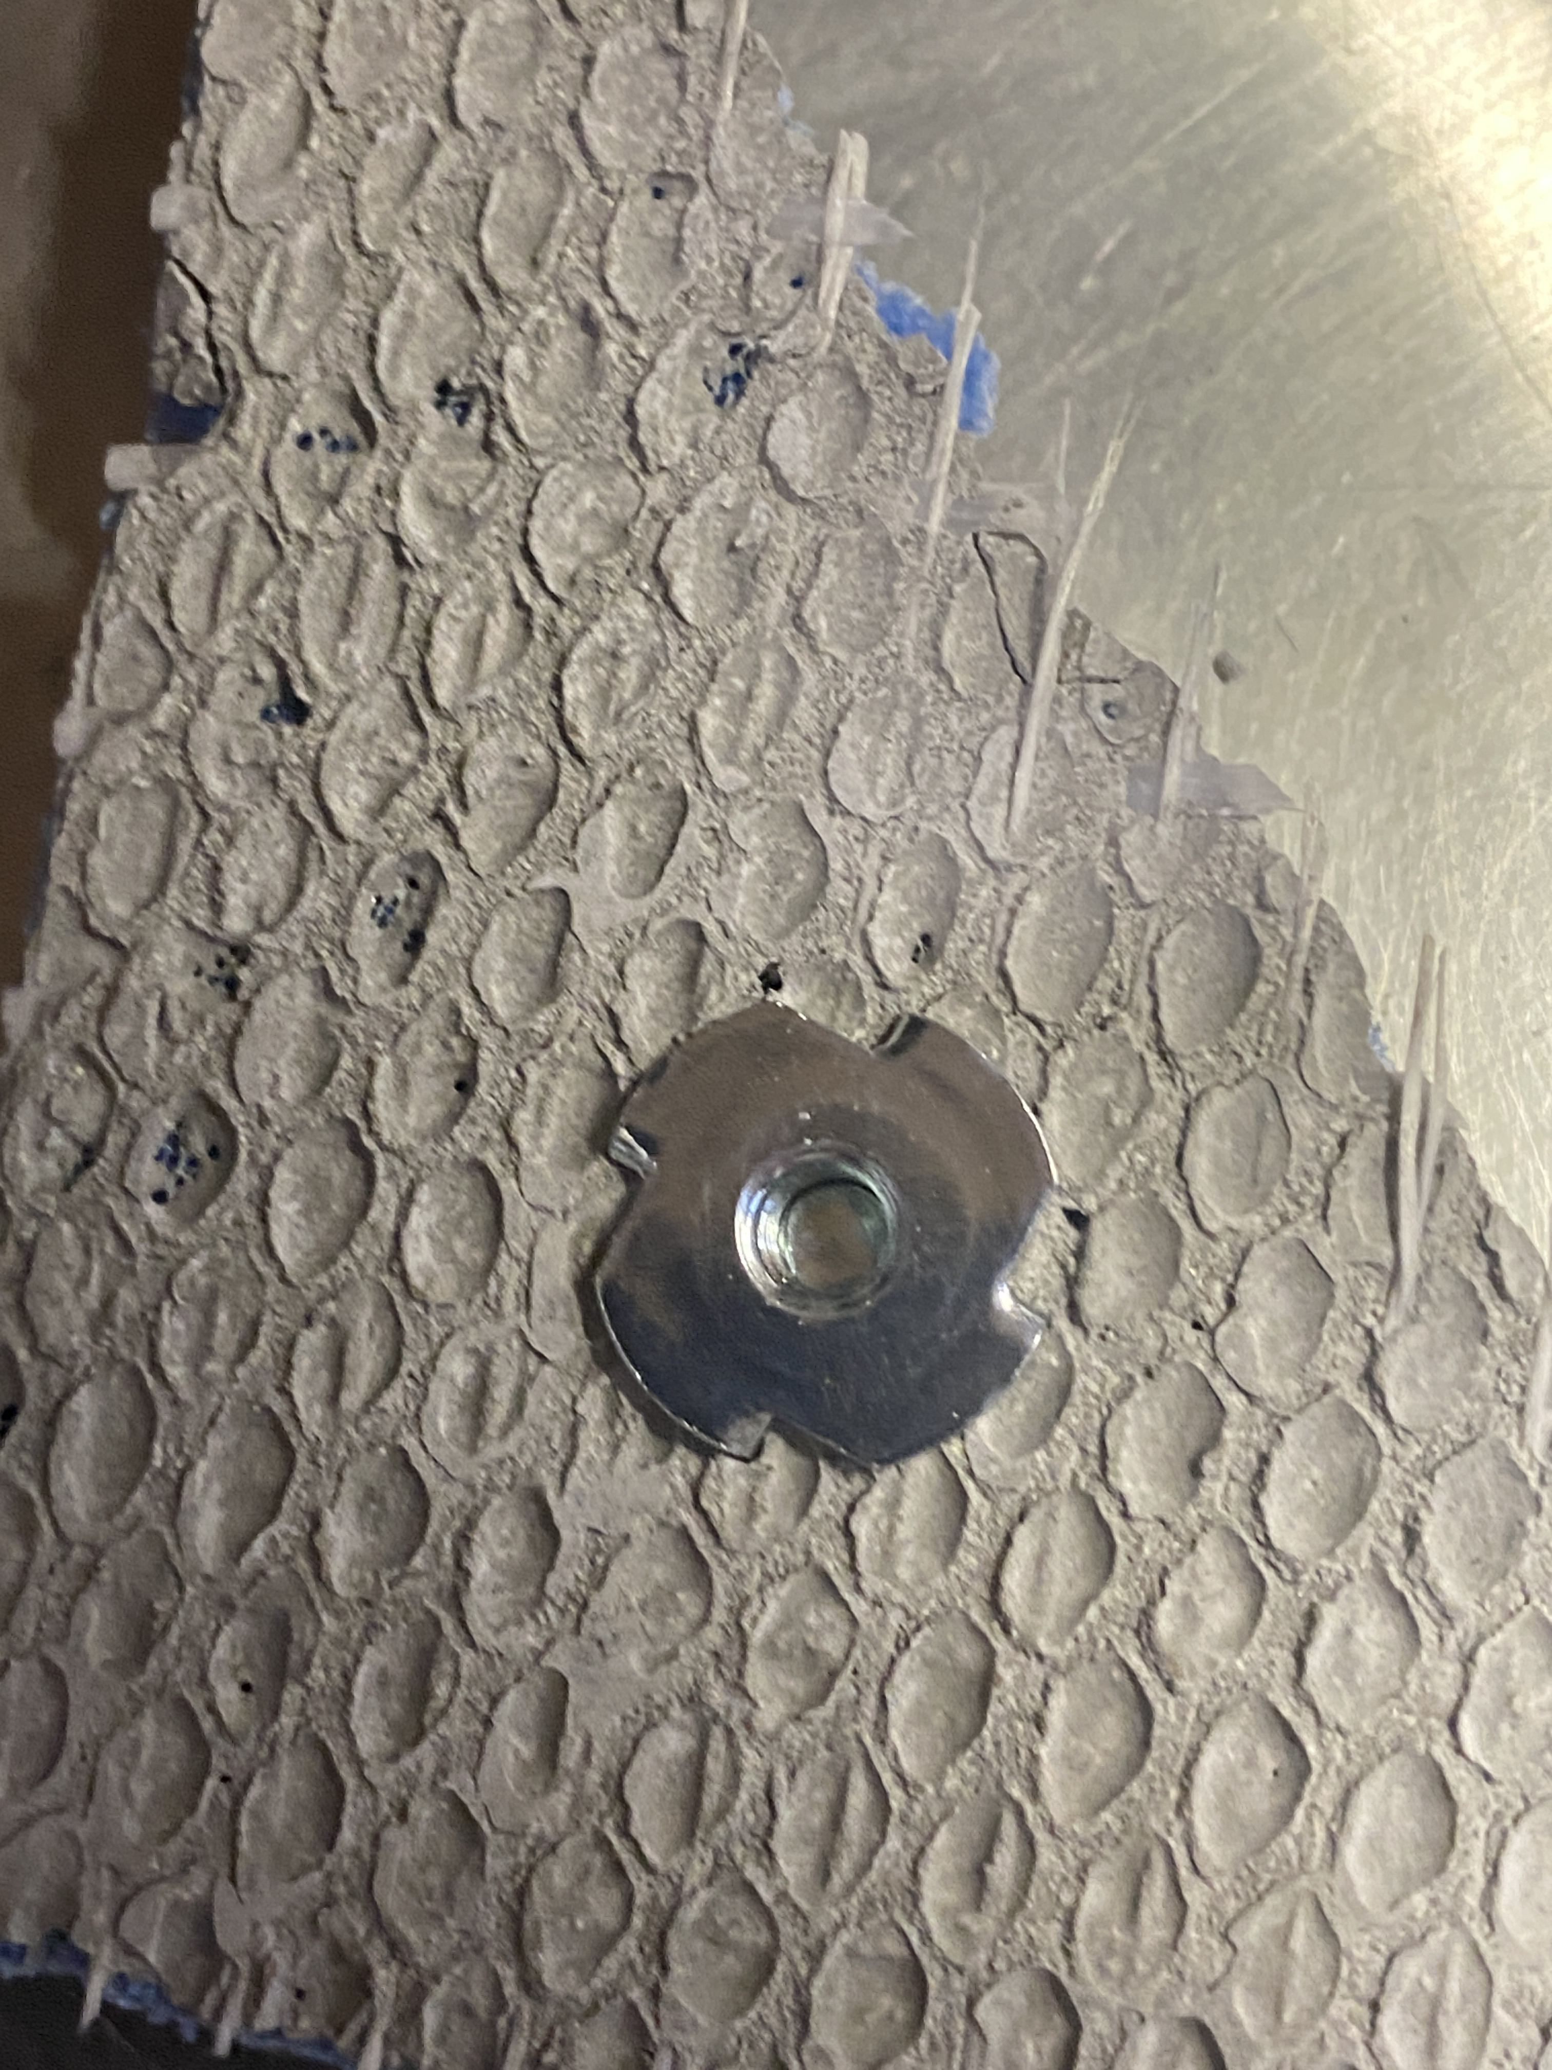
From the back, put the washer on, lining up the holes. Then slip the D-ring onto the bolt, insert into the hole and hand tighten into the T-nut. | 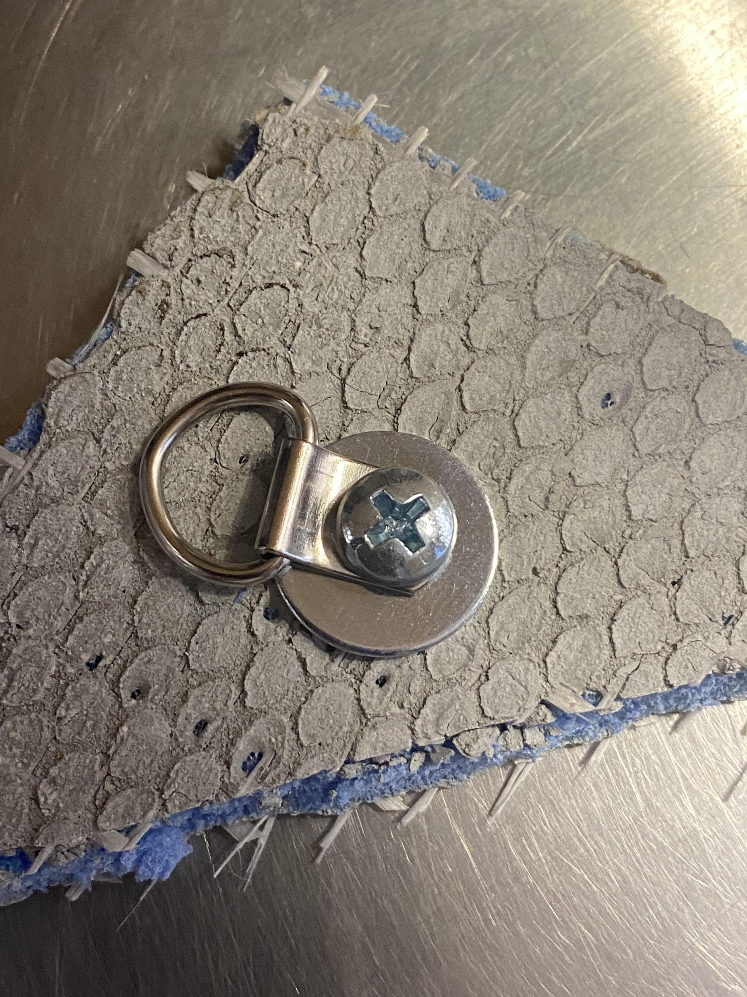
Tighten the bolt with a screwdriver until the T-nut pulls into the board and becomes flush with the surface. | 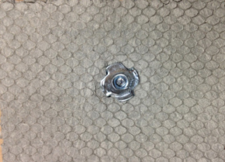
You can glue directly over the T-nut because it lies flush with the surface, and there is no need for a skim coat. If the board is to be unframed, the foam edges need to be protected in some way, especially if the piece is going outside. A thin layer of cement-based adhesive is good for this. For extra security you can cover the sides with alkaline-resistant fibreglass mesh tape before applying the cement-based adhesive. It is not advisable to use grout as it has no adhesive properties and will chip off over time. The edges of the board can then be painted if required.

Merlin Mosaica supplies fixings that include special washers for protecting the surface, allowing bolts to secure D rings for a hanging mechanism. The D rings are rated at 25kgs each, so two of them can support a 50kg mosaic project.

